**Education Corner Troubleshooting**

**Restarting iPad**

* Hole in back of mount, exposes power button

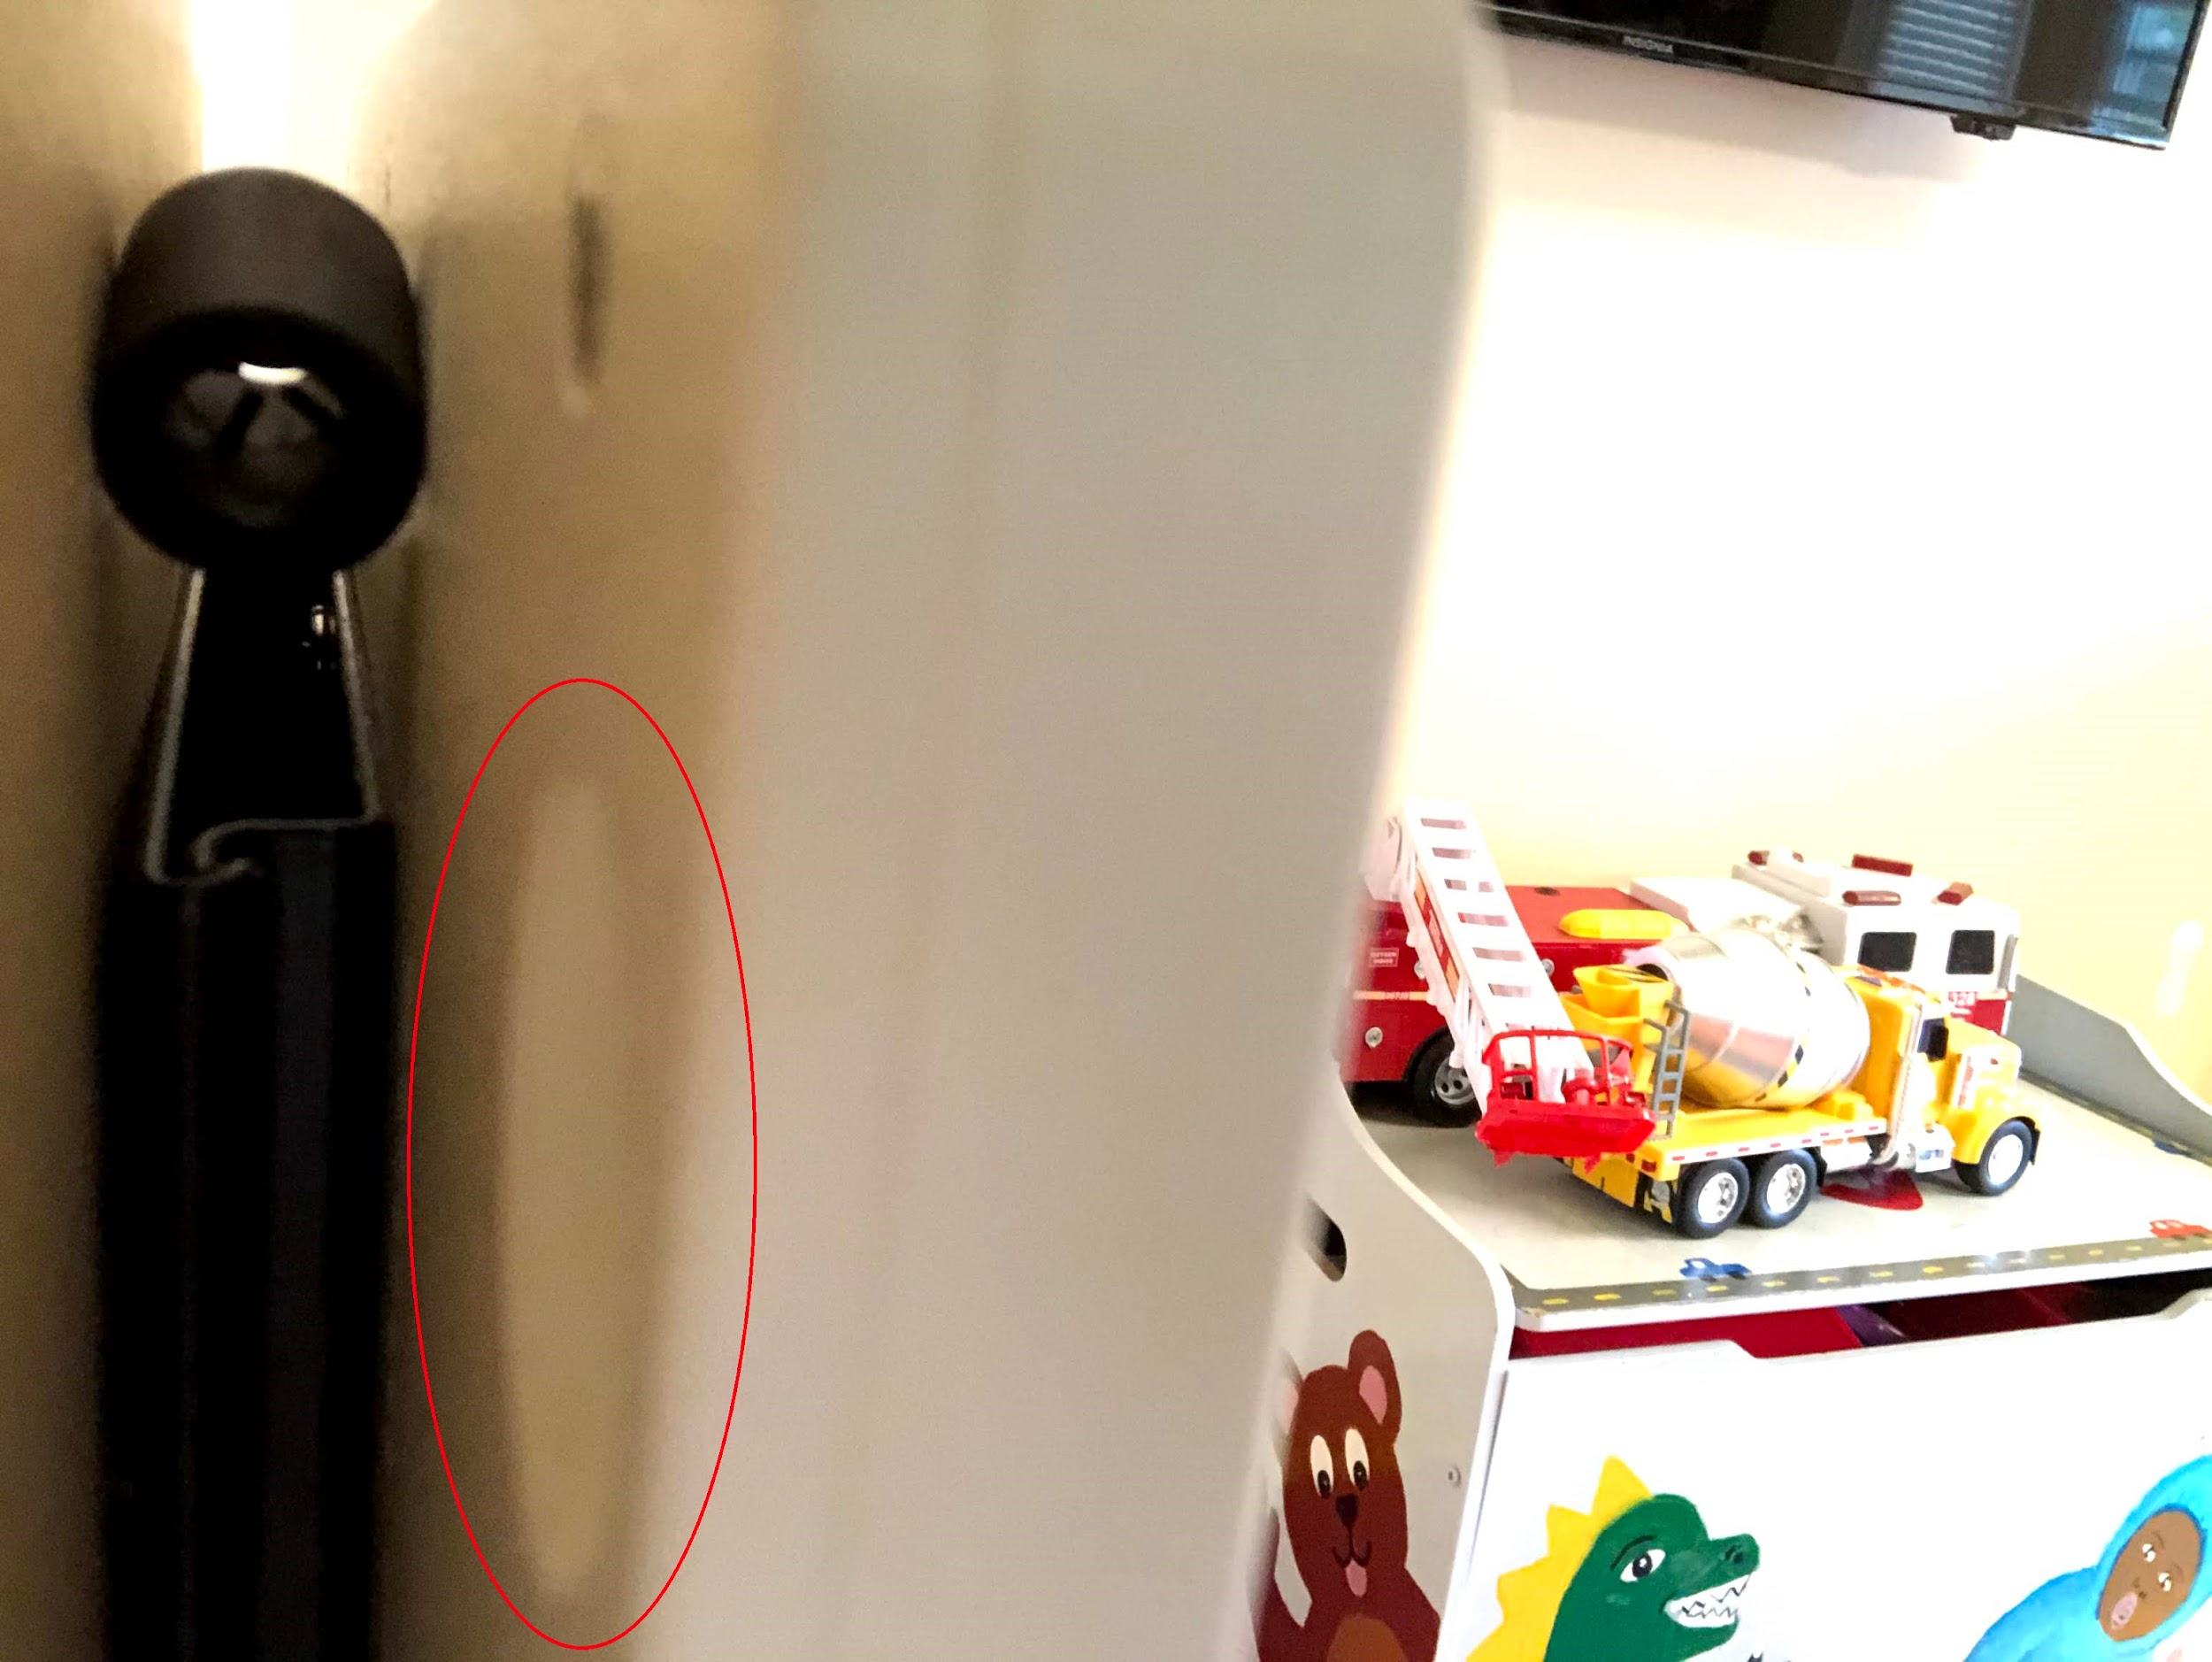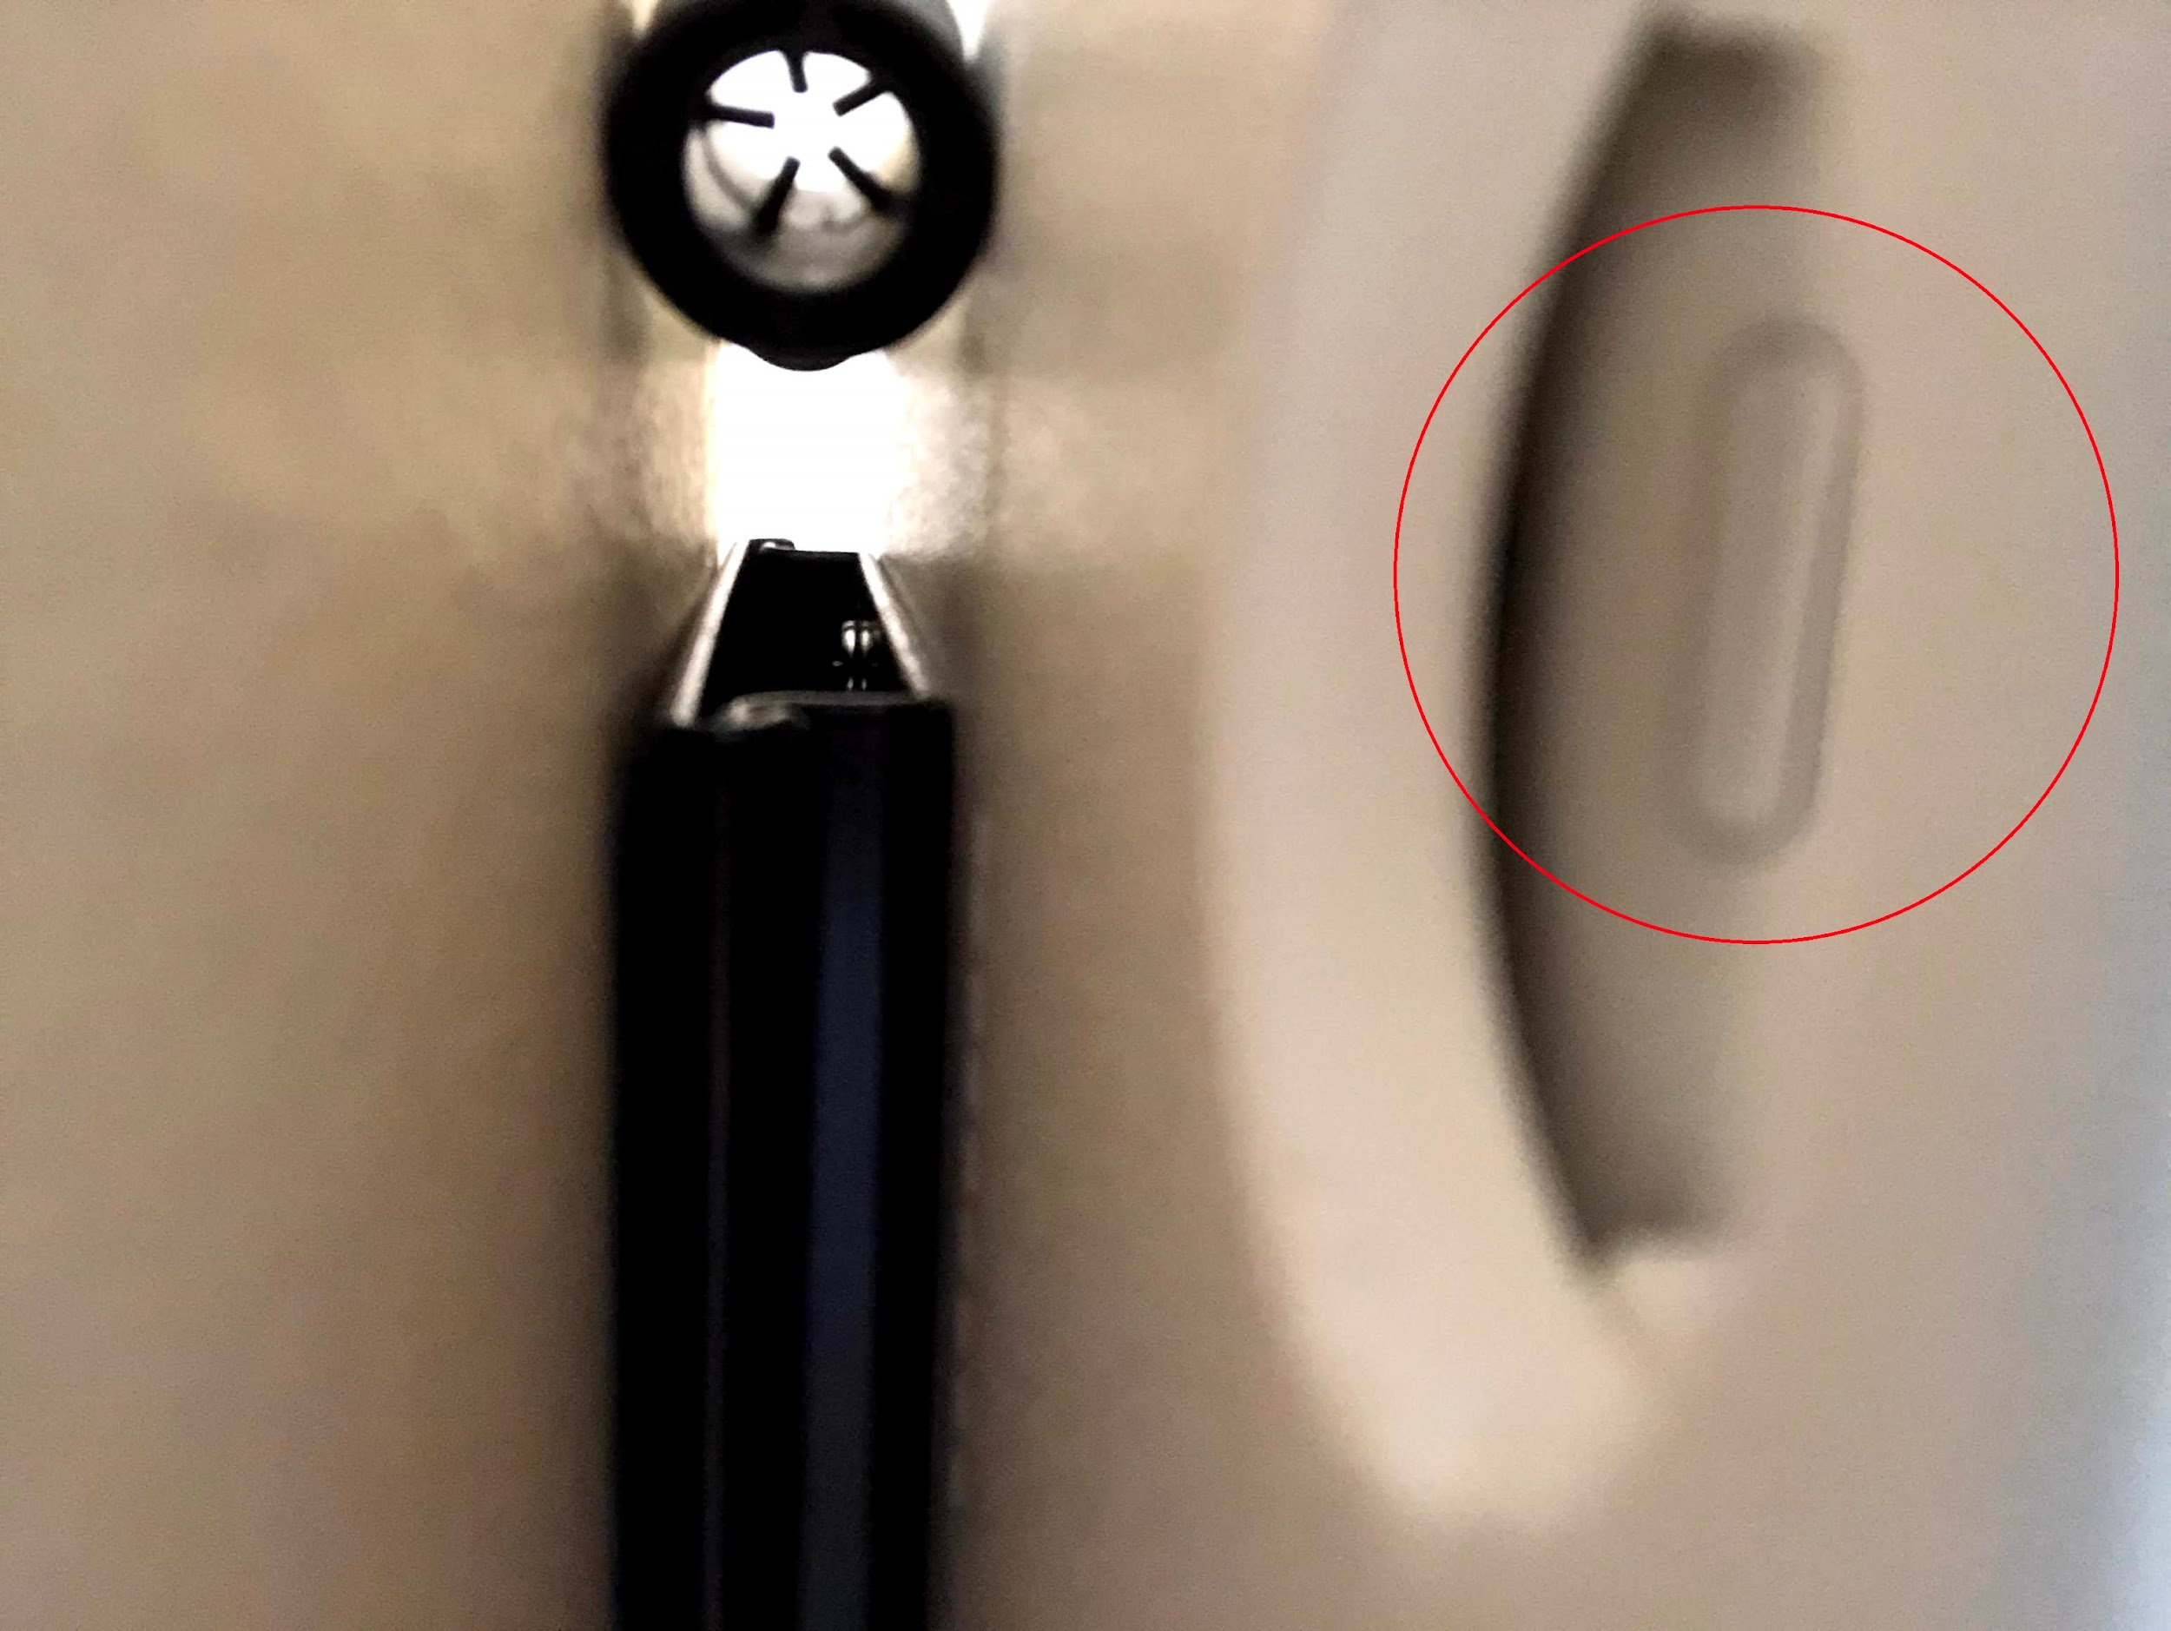

**Sound Coming Through iPad?**

* Turn the TV off then on again
* Restart the iPad

**Shutdown Procedure**

* Power off iPad completely using power button
* Make sure TV is off, black screen could still on but just reflecting iPad sleep mode (also black screen)

**TV Not Reflecting iPad / “No Signal”**

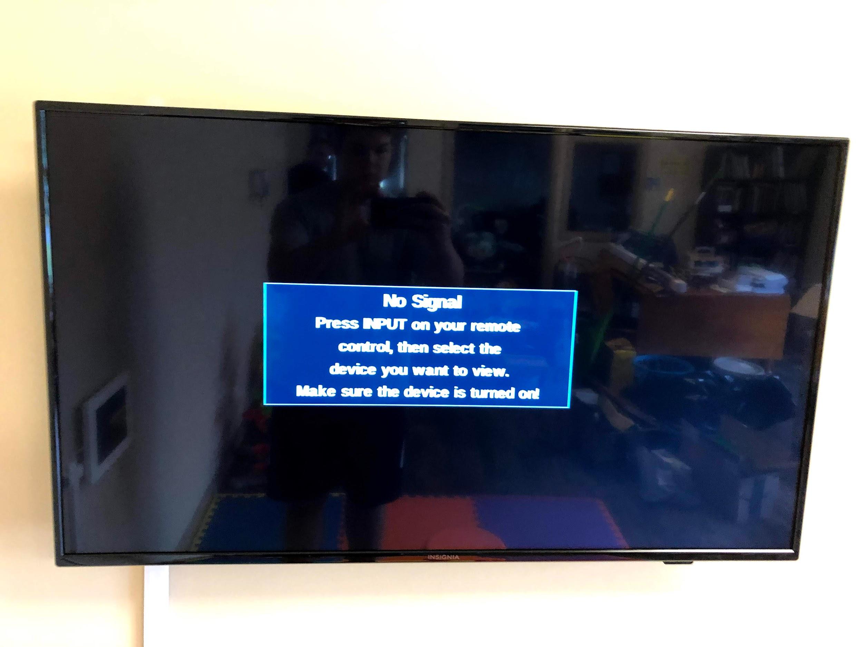

* Ensure TV input is on “iPad” to reflect iPad screen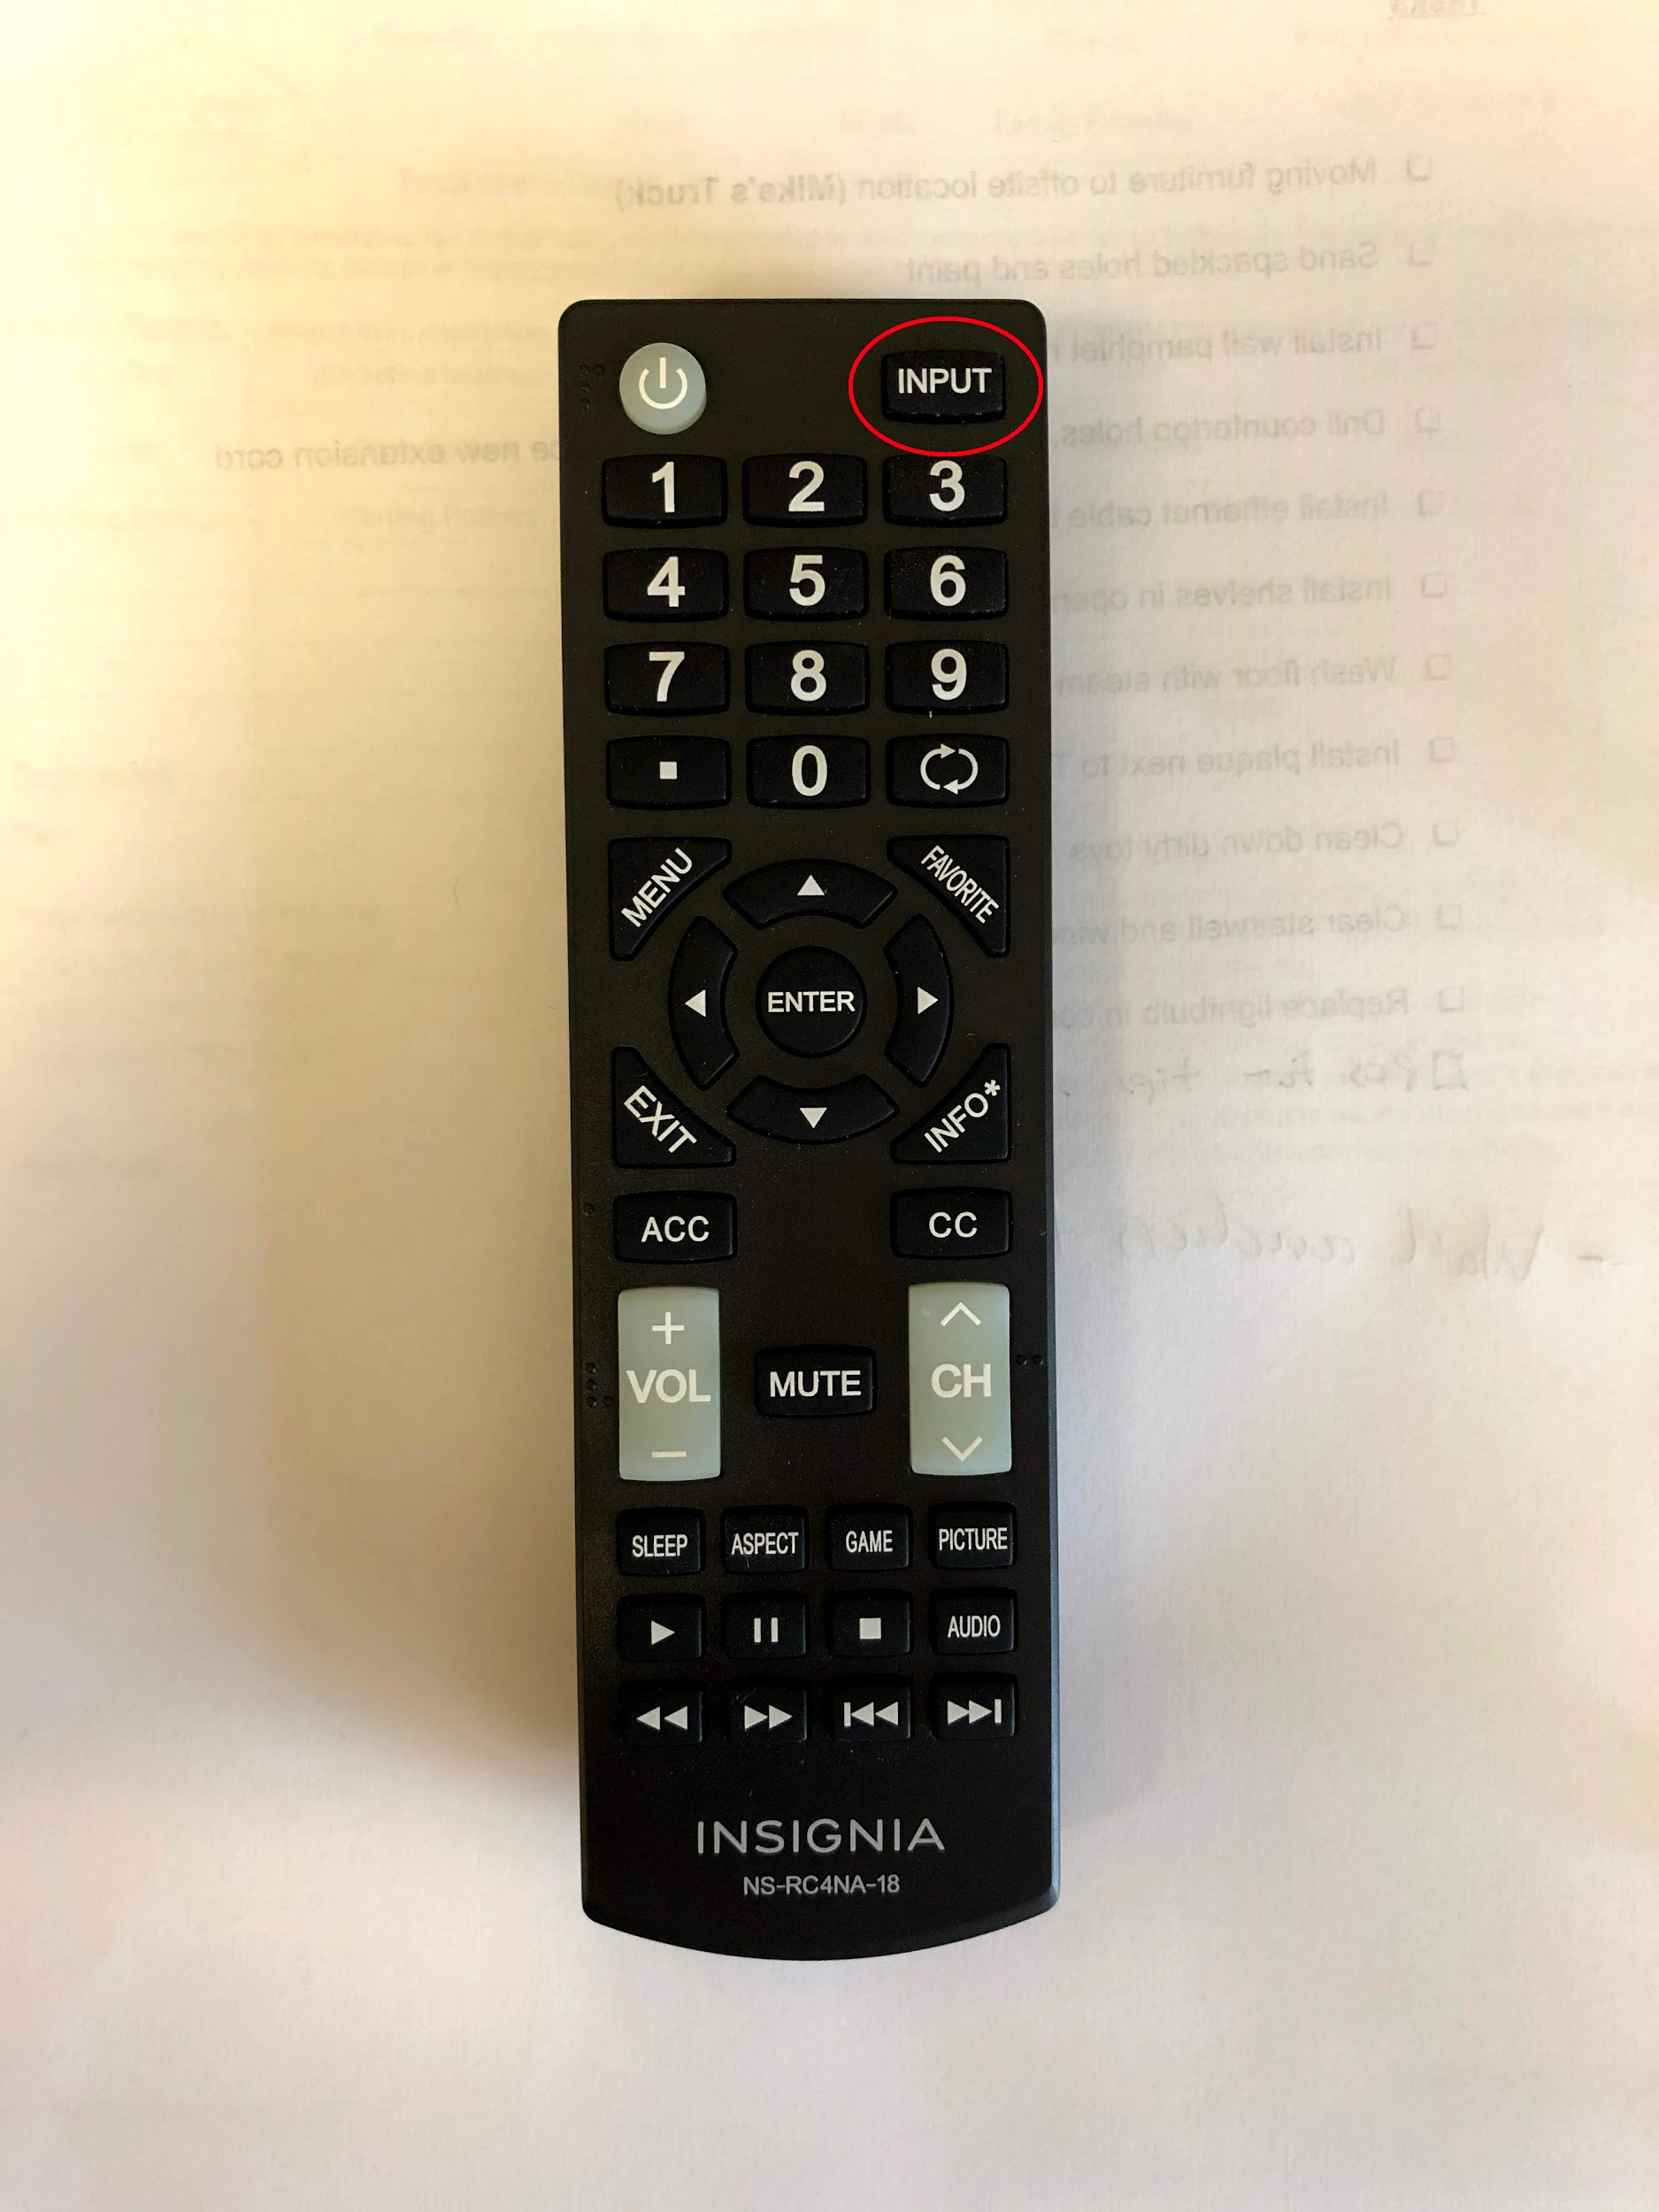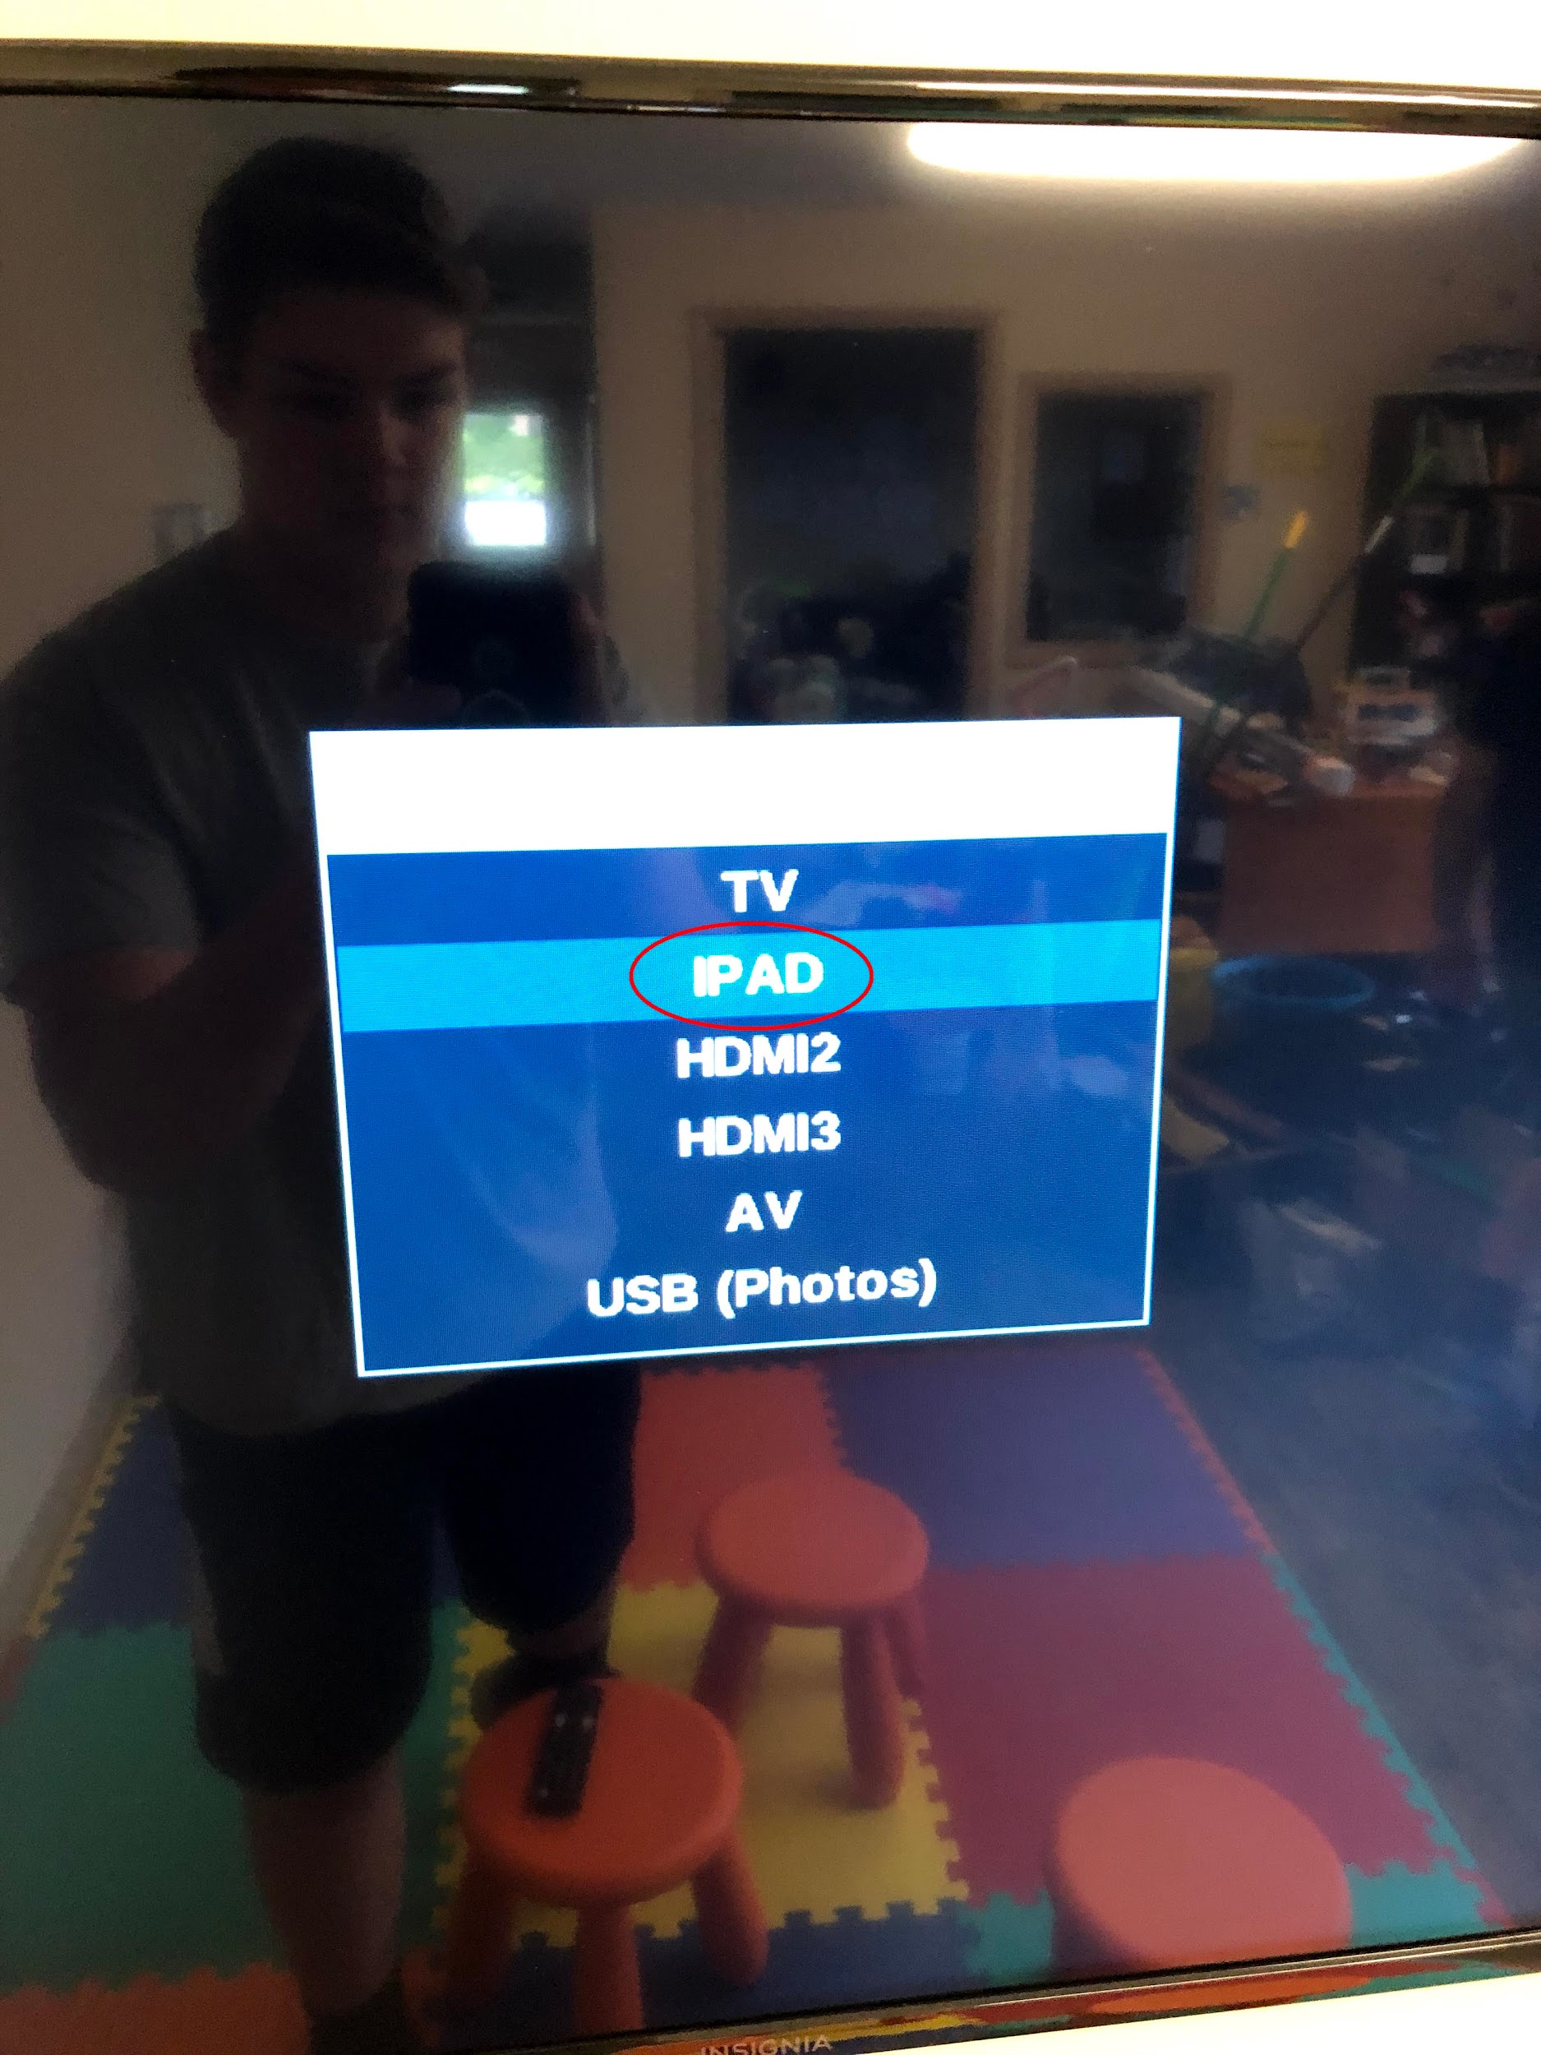
* Restart iPad and TV
* Ensure HDMI cable or iPad power cable did not disconnect (should be plugged into “HDMI1” on TV, renamed to “IPAD” in the input menu)
* Wire coming out of iPad mount could have disconnected from iPad inside mount
  + If this happens, remove the mount from the wall with a screwdriver and open up the back. Check to see that the cable is still plugged into the charger port
  + 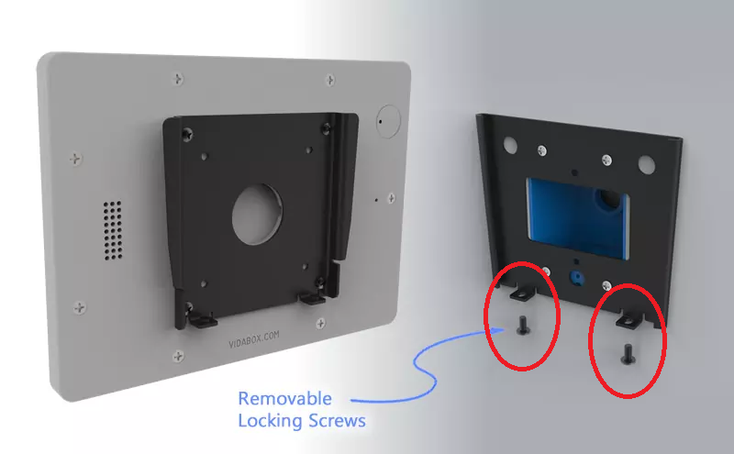
  + 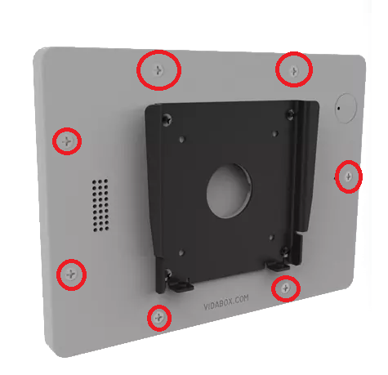
  + 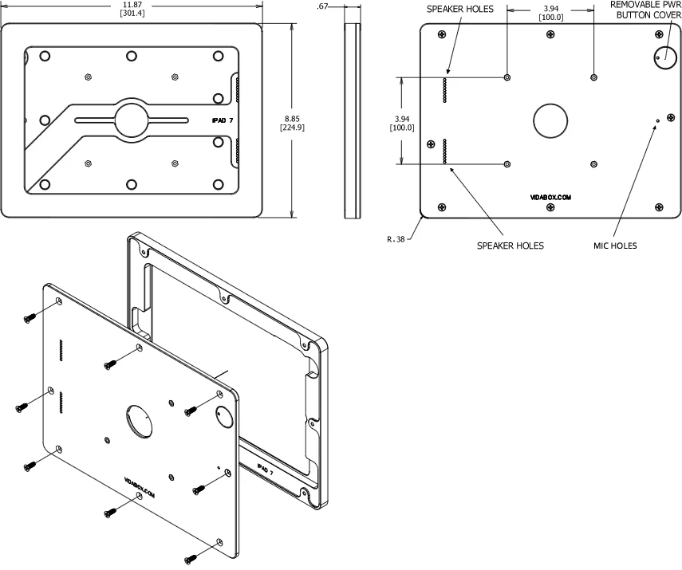
  + Any more help, <https://www.vidabox.com/kiosks/vidamount-fixed-wall-ipad-tablet-mount.html> (iPad 7th Gen 10.2” case)

**Website Blocked On iPad**

* Website whitelist is located in “Misc” Folder
* > “Settings”
  + 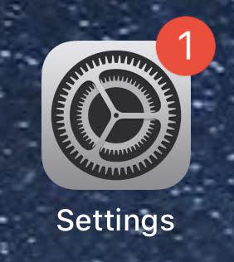
* > “Screen Time”
  + 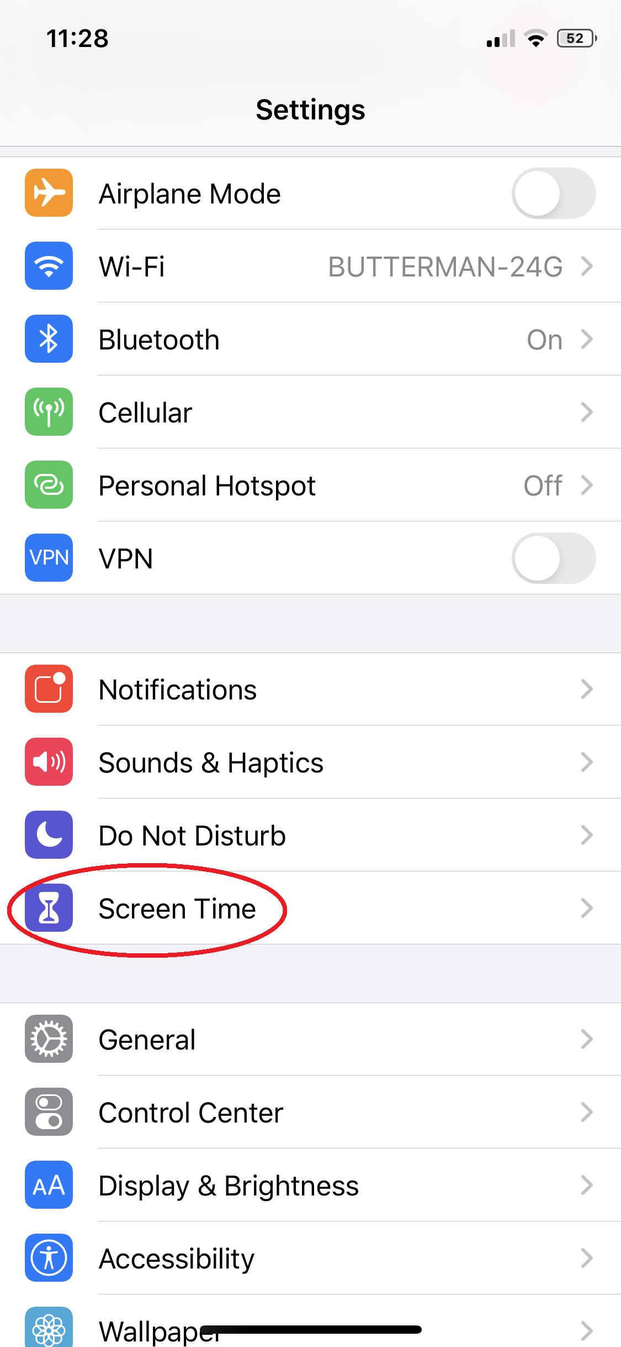
* > “Content & Privacy Restrictions”
  + 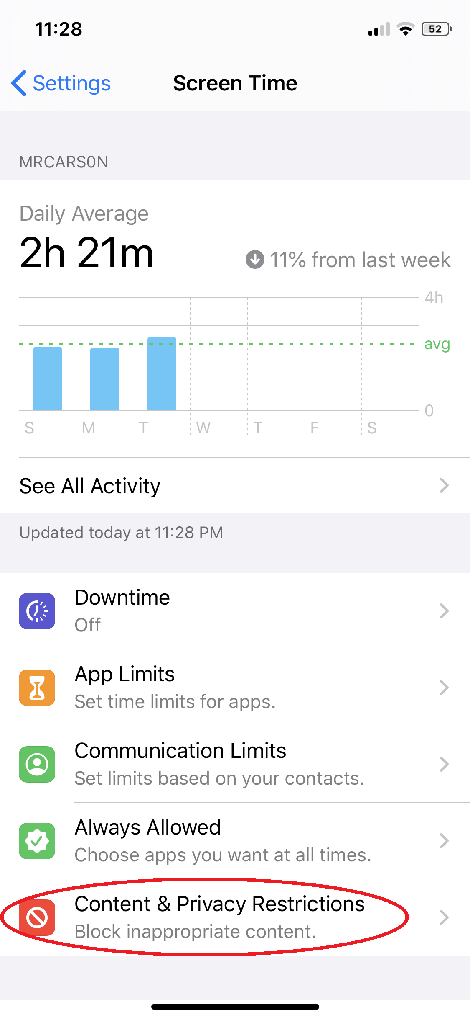
* > “Content Restrictions”
  + 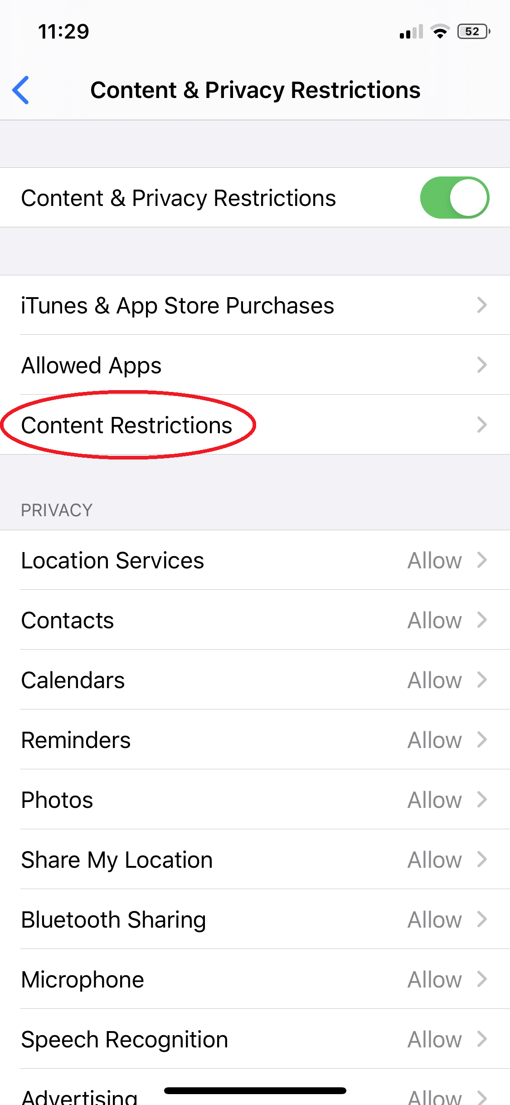
* > “Web Content”
  + 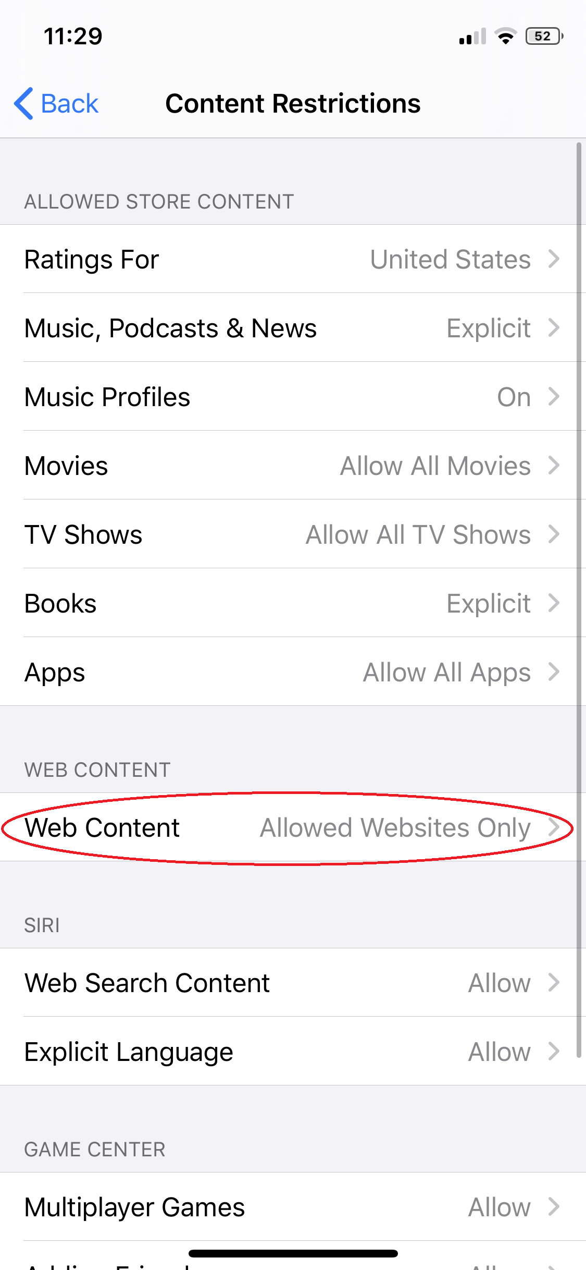
  + To whitelist a website, click “Add Website” and enter the URL and name
    - 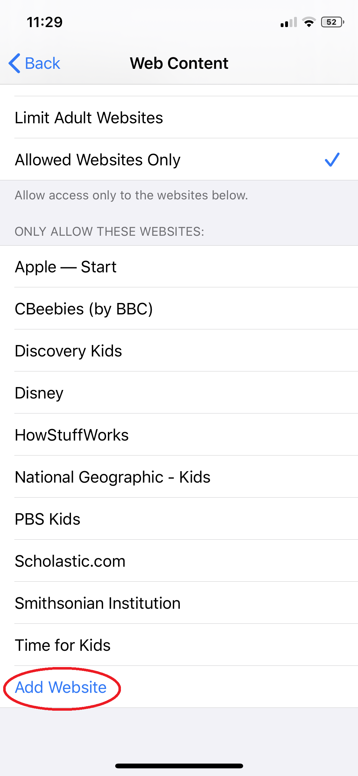
    - 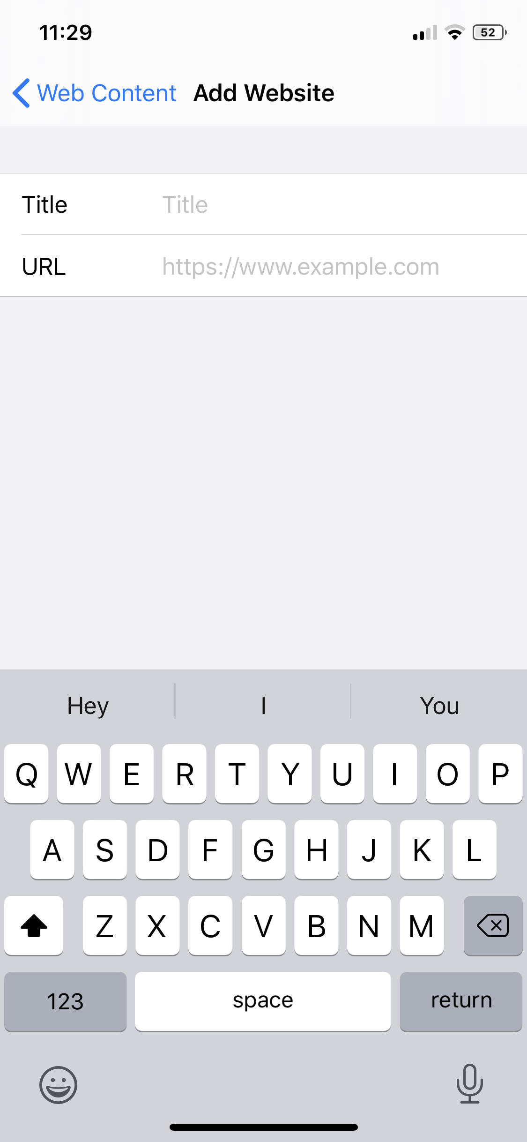
  + **NOTE: Need Screen Time Passcode from Mrs. Angela Mountz**

**iPad Mount Wiggling**

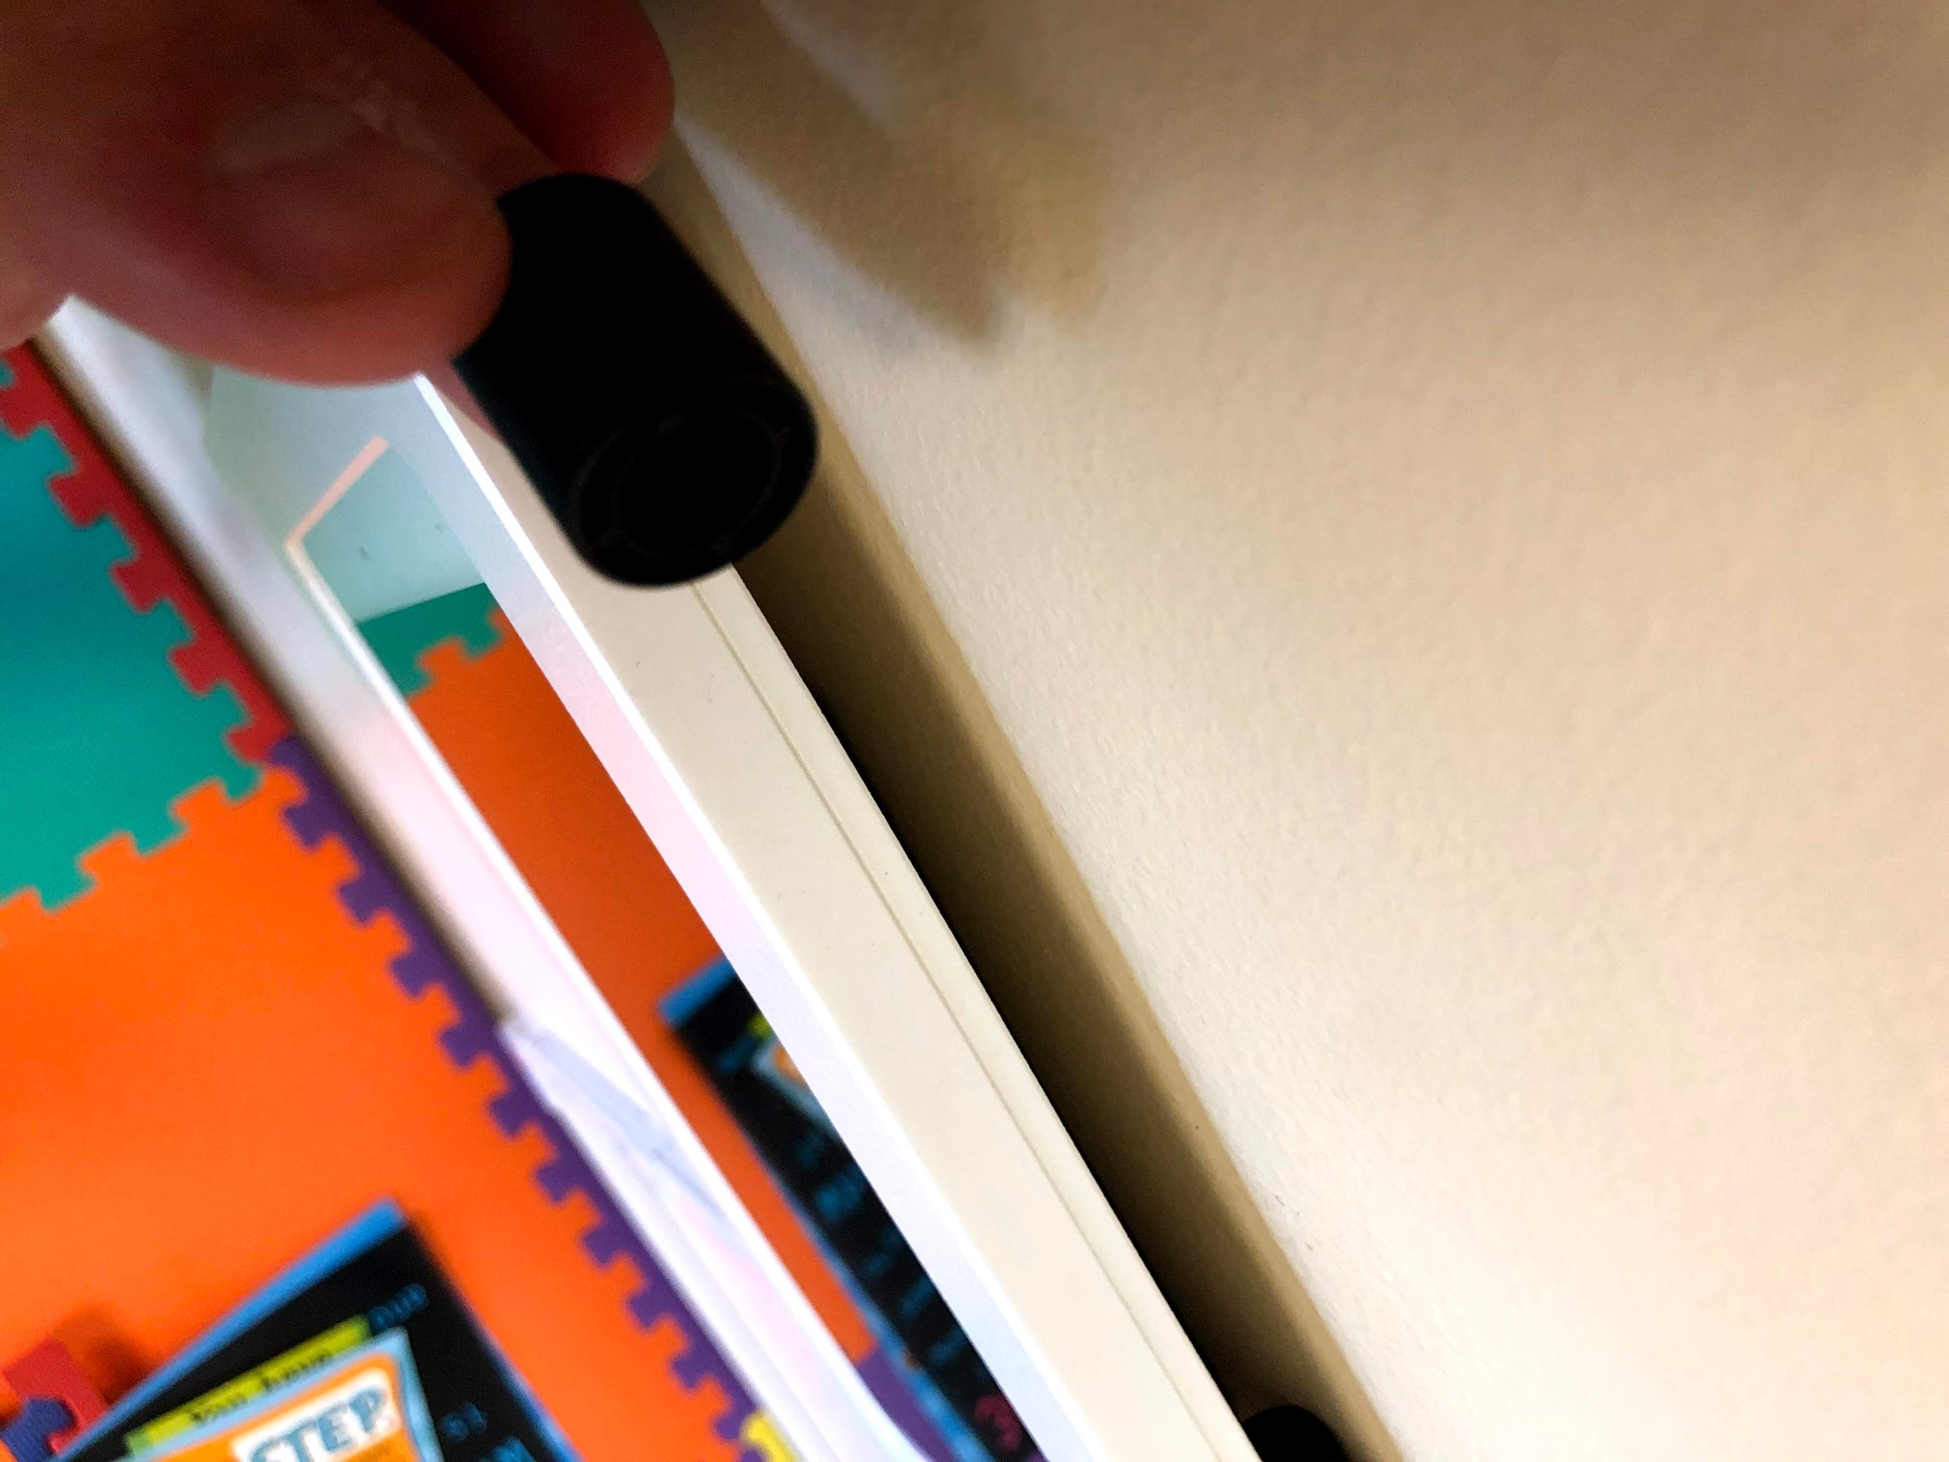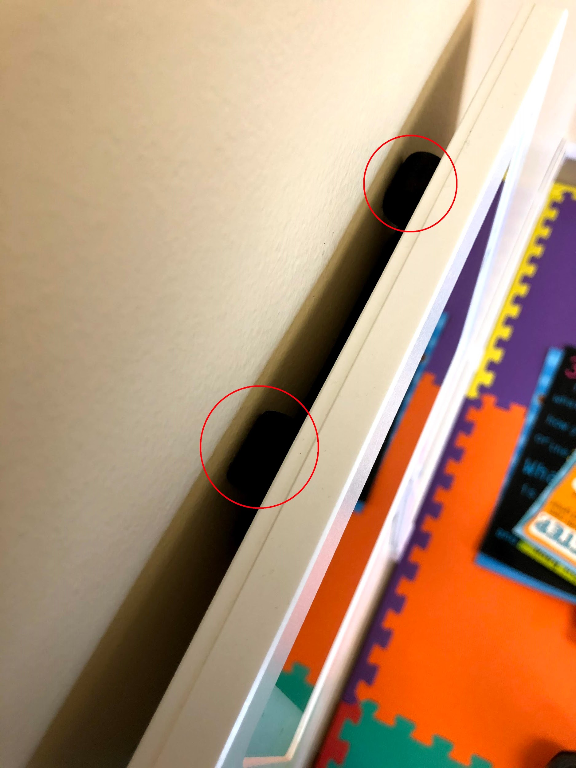

* Wedge any small item tightly in between iPad and wall gap

**Unknown Small Black Piece Falls Out From Behind Mount**

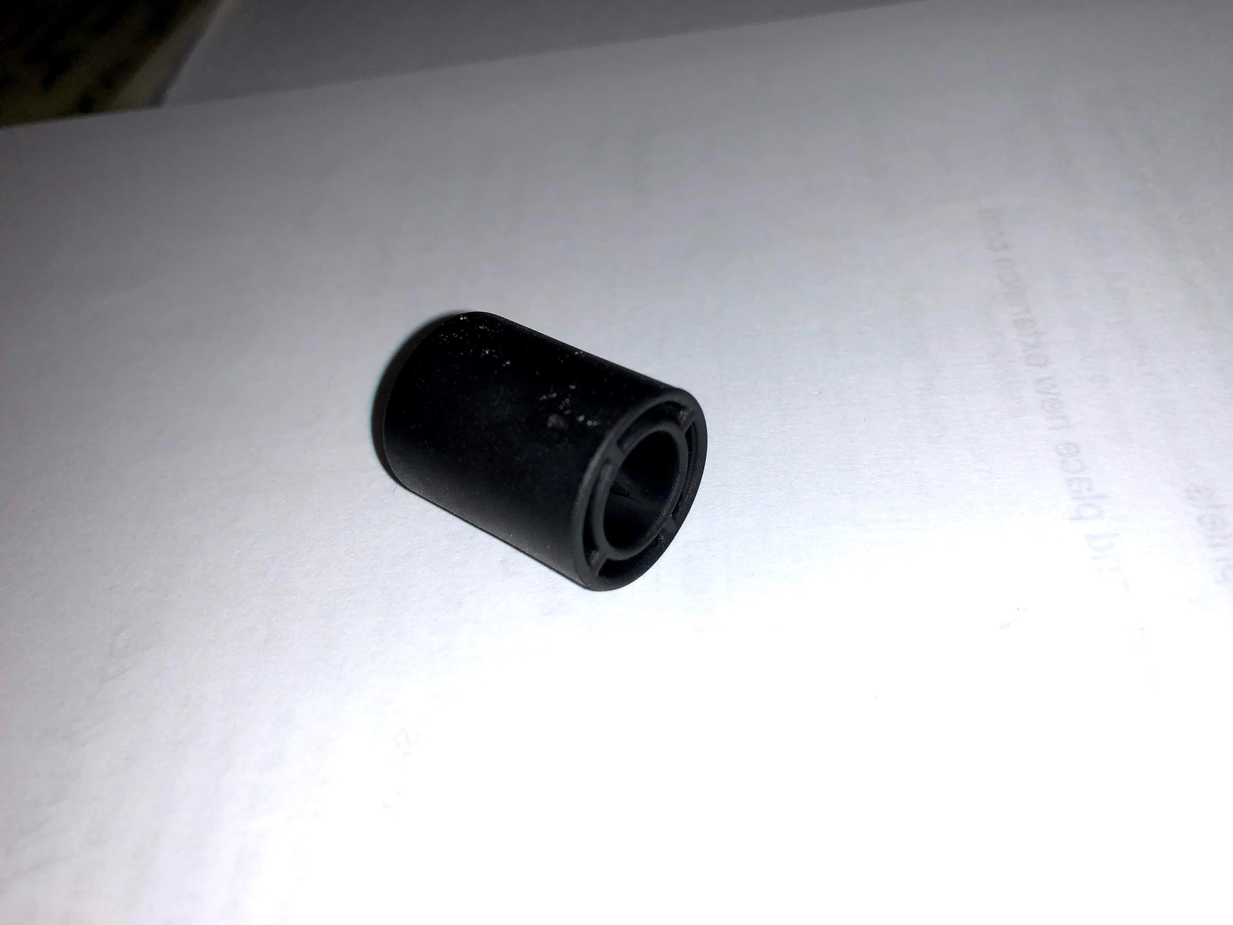

* The piece is a wedge placed to prevent the mount from wiggling, could fall so you can just squeeze it back behind the mount